Pokhara University

Level: Bachelor | Semester – Spring | Year : 2009
Programme: BE |  | Full Marks: 100
Course: Electronic Circuits I |  | Pass Marks: 45
 |  | Time : 3hrs.

Candidates are required to give their answers in their own words as far as practicable.
The figures in the margin indicate full marks.

Attempt all the questions.

 | - Draw Two Stage RC coupled Amplifier circuit. What are the main advantages of RC coupling over direct coupling?  - Calculate Voltage gain, input impedance and output impedance for the given BJT amplifier. (Draw necessary equivalent re model). (Assume β = 100, re= 20Ω)  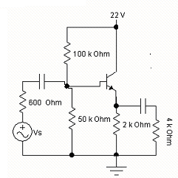 | 8  7
 | - What is the effect of bypass capacitor on Low frequency response of BJT ( Self Bias ) amplifier? Explain  - Define cut off frequency. For the circuit given below, find the value of lower cut off frequency. Assume β = 100, re = 20Ω , ro = 200K Ω  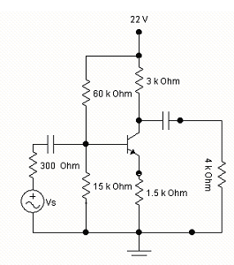 | 8  7
 | - Draw Transformer Coupled Load Class A amplifier and derive its expression of efficiency.  - Briefly discuss Class B Power amplifiers. What is cross over distortion? | 8  7
 | - What are the main characteristics of Negative Feedback? Briefly explain how negative feedback improves gain stability.  - An amplifier has an open loop gain of 600 and a feedback ratio of 0.20. If the open loop gain changes by 15 % , find the percentage change in closed loop gain. | 3+5  7
 | - What are the conditions of Oscillations?. Draw RC Phase shift Oscillator and explain its operation. Derive the expression of its resonance frequency  - Draw LC tuned Hartley oscillator and explain its operation. | 8  7
 | - Draw full wave center tap rectifier circuit and explain its operation. Derive the expression of its average voltage, rms voltage and Ripple factor  - Briefly Explain how shunt capacitor filter works? | 8  7
 | Write short Notes (Any Two):  - Choice of BJT configuration in intermediate stages while cascading  - Miller’s Effect  - Voltage Series Negative Feedback | 5×2

